Garbage Collection

* Garbage collection is also called DE allocation of memory.
* Garbage collection is a process and it is part of JVM.
* It perform on Heap area and Meta space only. In stack area GC process won't be applicable. Because it clear garbage automatically.

Def.: It is process of deleting the unused, unreferenced, anonymous objects in order to free up the memory which can be used for latter point of time.

Usages:

* It is introduce to use the memory efficient, because we have limited memory.
* Main use of garbage collection is to increase performance and to avoid the space issues.
* With some regular intermission and with some condition in java garbage collection will done automatically.
* We can done manually also.

Process:

* If we create Objects, Those objects will place in Heap memory.

In heap area we have two types of generations:

1. Young generation

2. Old generation

Young generation: Perform minor garbage collections.

* In young generation again we have three sections.
* Eden space
* Whenever we create an object it will store in Eden space.
* If Eden space is going to full then Garbage collector will call automatically.
* Garbage collector identify unused objects, unreferenced objects, anonymous objects and perform MSC.
* M ->Mark ->it mark objects
* S->Sweep ->it will delete
* C->Compact ->it arrange proper way for better performance.
* Serviour space(s0)/ from space
* After performing MSC, still objects are present then those objects will move to s0 (From space) from Eden space.
* Till now minor garbage collections done.
* Serviour space(s1)/ To space
* Again if we create some objects and objects will store in Eden space. And perform MSC and reaming objects are placed in s1 (To space).
* Note: Before we performed one MSC operation and some objects we stored in s0 (From space). Now Those Eden space remaining objects and so space objects will move to s1 space and keep s0 space Empty.
* Why because if one minor garbage collection process done it always try to keep in empty space.
* In young generation always one space is free.

Old generation: Perform Major garbage collection.

* After 15 minor garbage collections still objects are present in s0 or s1 then those objects will move to old generation.
* After moving to old generation Eden space, s0, s1 become free and in old generation also garbage collection process will perform.

Meta space: It also perform major garbage collection.

This is the process of garbage collection automatically done.

How to perform manually?

We can call in two ways:

1. System.gc();

2. Runtime.getRuntime().gc();

Difference between Garbage collection and Garbage collector?

* Garbage collection is a process.
* Garbage collector is a tool that perform this deletion operations.

Iteration1:

* Total in 2 memory spaces garbage collections will perform

1. Eden space: Again in Eden space we have two generations

* Young generation : In young generation we have 3 frames
* Eden space
* s0 (From space)
* s1 (To space)
* When we create objects it will store in Eden space.
* It will wait for some time and marks unused, anonymous, unreferenced objects. After marking objects will garbage (sweep) from Eden space.

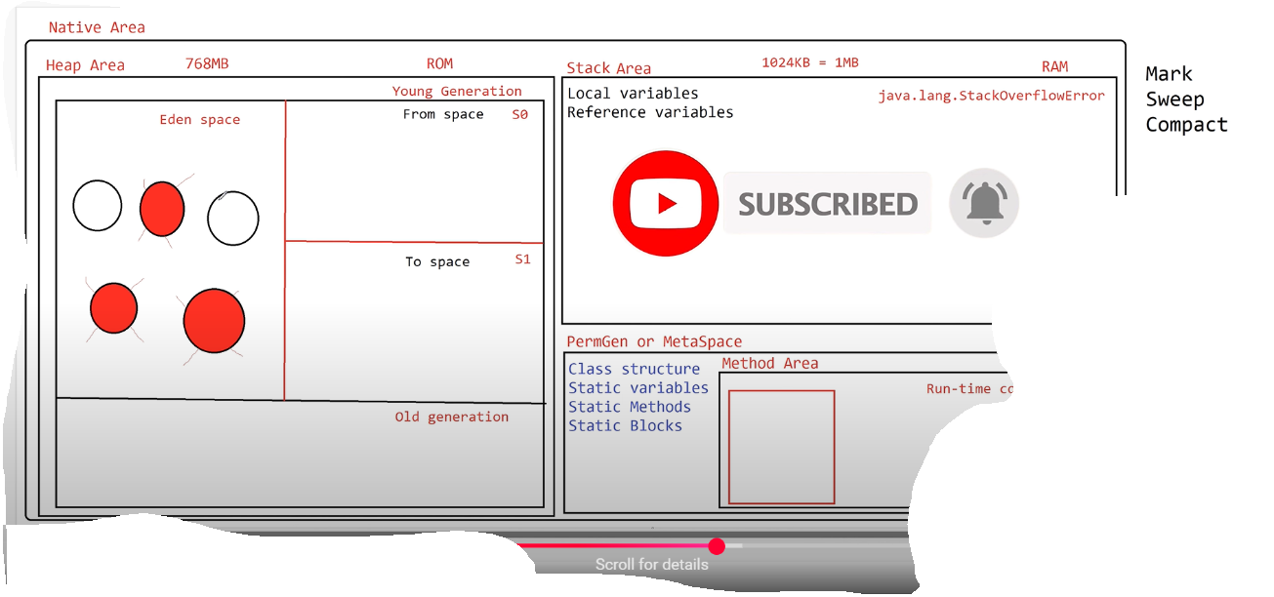

* After sweep in Eden space still objects are present in Eden space those objects will compact (means arrange objects side by side for better performance).

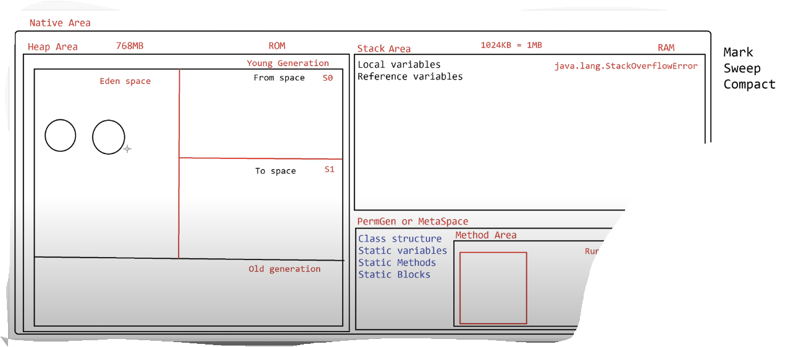

* After compact objects will move to s0 (from space).

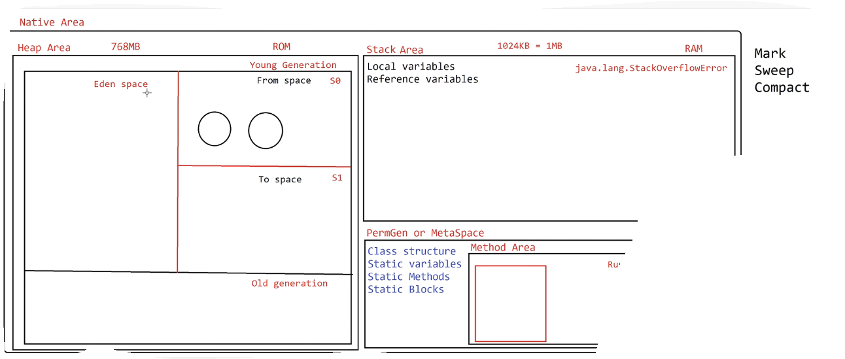Iteration2:

* Again we create objects and objects will store in Eden space. And perform MSC operations.
* Now MSC operations will perform on s0 space also.

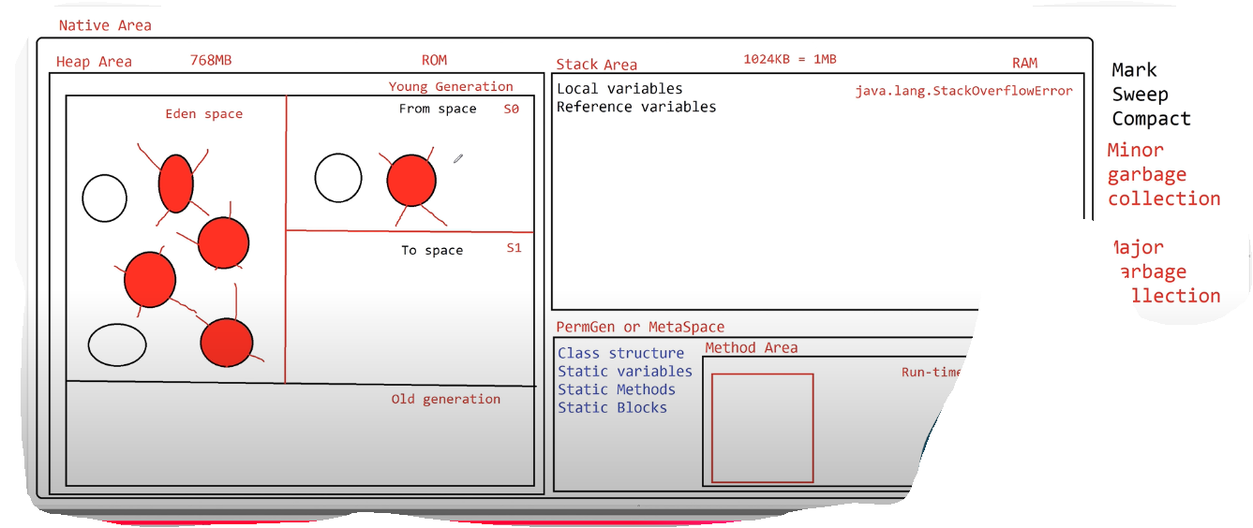

* After sweep reaming objects in Eden space and s0 will compact.

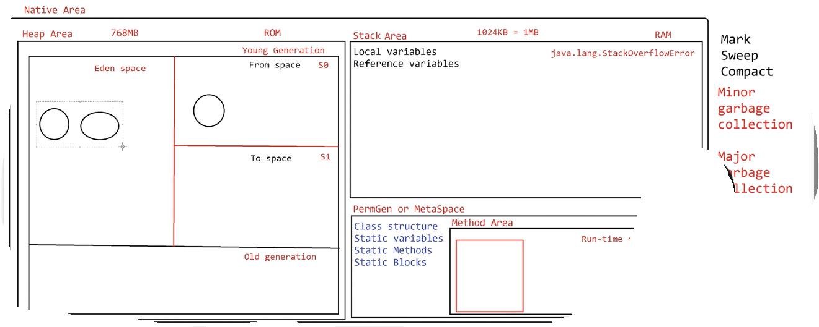

* After compact objects will move to s1 (To space). In any iteration either s0 or s1 will be empty.

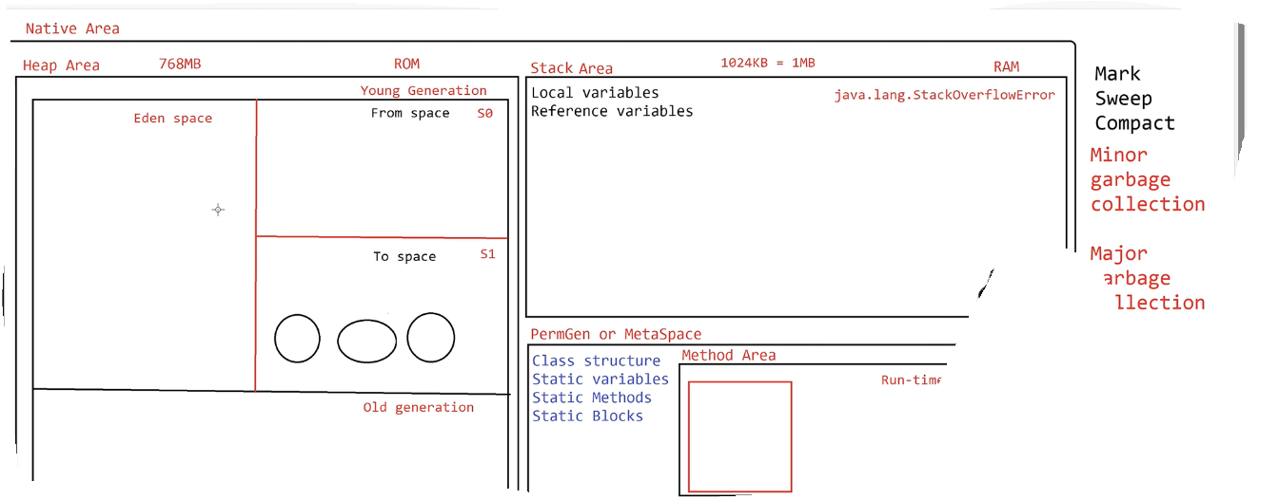

Iteration3:

* Perform MSC operations.

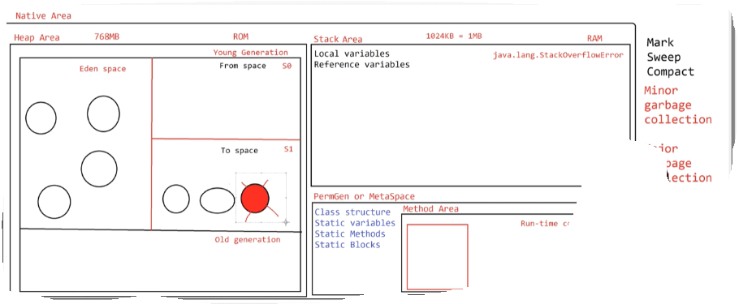

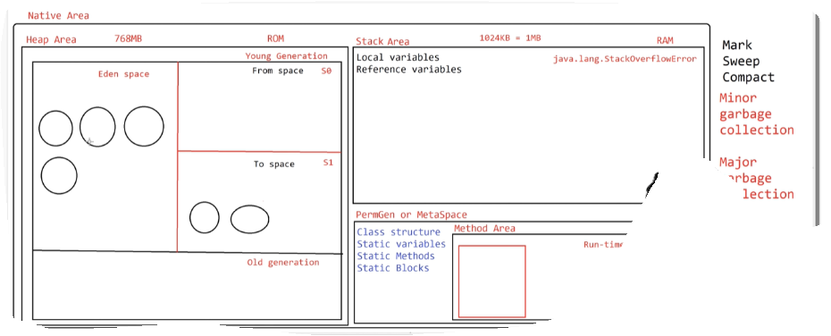

After performing MSC operations reaming objects moved to s0, and s1 space is Empty.

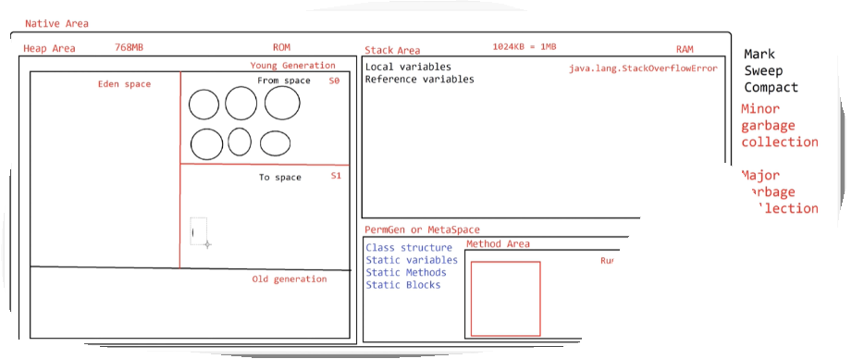

* Old generation:
* After completing 15 iterations still objects are present in s0 or s1 space then those objects are moved to old generation.

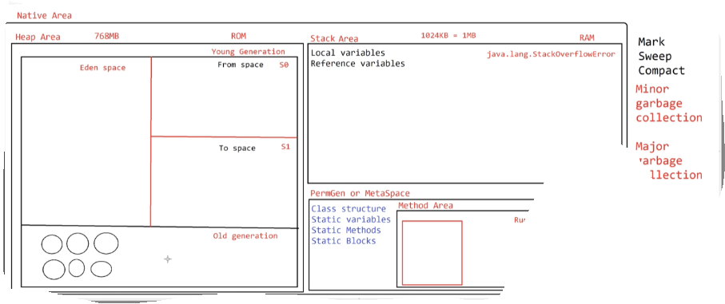

* In old generation also MSC operations will perform frequently.

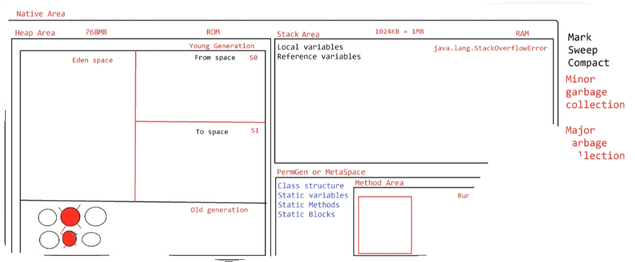

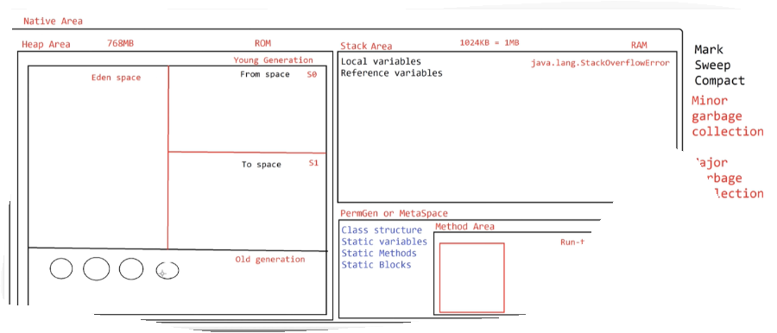

2. MetaSpace

In Meta space also MSC operations will perform frequently.

Code:

